**MOBILE EDGE**

**Market Overview**

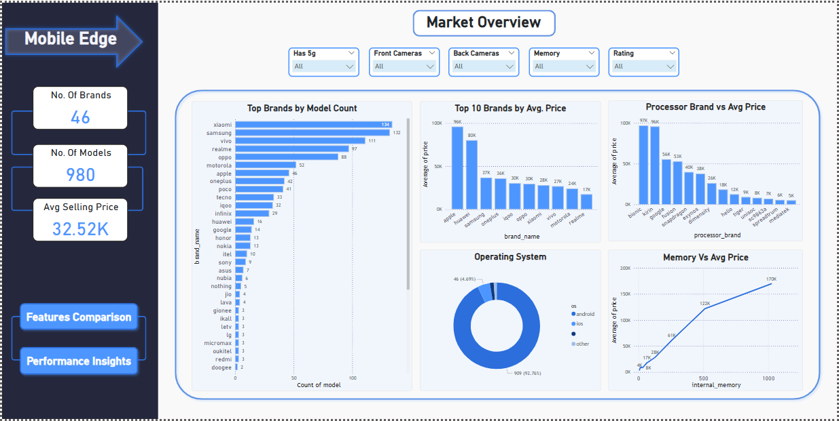

### ****1. Top Brands by Model Count****

“This **horizontal bar chart** shows which brands have the most smartphone models.”  
**Xiaomi** and **Samsung** lead with the highest number of models.  
This gives customers **more choices across all price ranges**, from budget-friendly phones to premium devices.

### ****2. Top 10 Brands by Average Price****

“A **bar chart** showing the **10 most expensive brands on average**.”  
**Apple** and **Huawei** have the highest average prices across all models.  
This indicates they **mainly focus on the premium market** with **high-performance and luxury smartphones**.

### ****3. Processor Brand vs Average Price****

“This chart compares **processor brands** with the **average price** of phones using them.”  
Phones with **Bionic** and **Kirin** processors have the highest average prices.  
These processors are mostly found in **premium smartphones** with strong performance.

### ****4. Operating System Distribution****

“A **donut chart** showing the share of each operating system used in the dataset.”  
 **Android dominates** the market with around **93%** of all models.  
Only a small portion uses **iOS**, mainly Apple devices.

### ****5. Memory vs Average Price****

“A **line chart** showing how internal storage affects phone pricing.”  
Prices increase gradually as memory increases, but **jump sharply** from **500 GB to 1 TB**, indicating a **premium price tag** for high-storage models.

**Features Comparison**

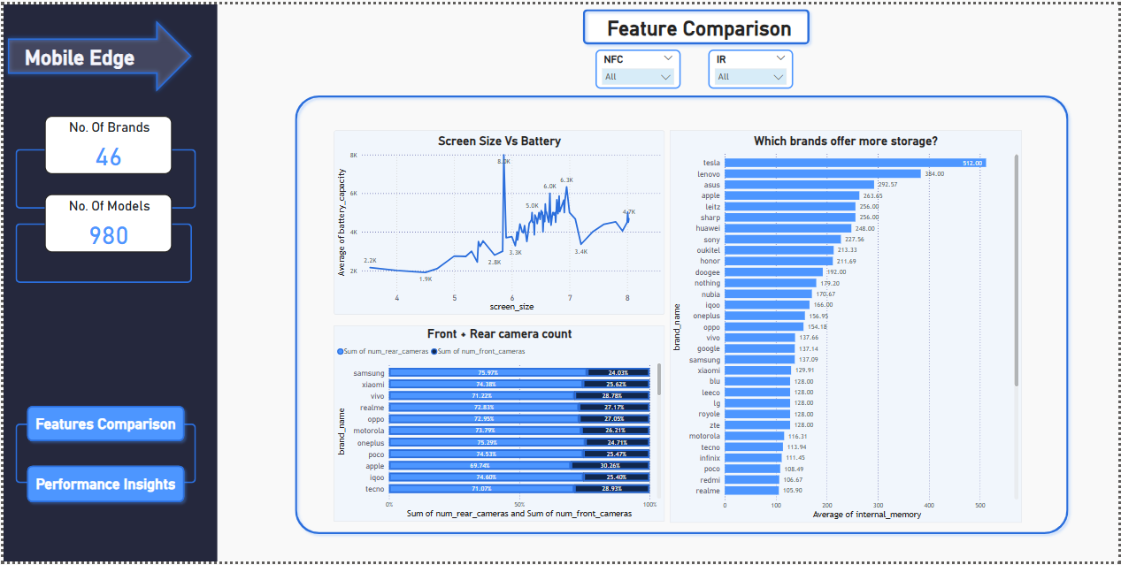

### ****1. Screen Size vs Battery Capacity****

“A **line chart** visualizing how **battery capacity changes** with screen size.”  
The general trend shows that **larger screens** are usually paired with **higher battery capacity** to support extended usage.

### ****2. Which Brands Offer More Storage?****

“A **bar chart** ranking brands by their **average internal memory**.”  
**Tesla**, **Lenovo**, and **Asus** offer the **highest storage options**, going up to **512 GB**, which is ideal for users who store large files, videos, and apps.

### ****3. Front + Rear Camera Count by Brand****

“A **grouped bar chart** showing the **total number of cameras (front + rear)** per brand.”  
For example, **Samsung has ~76% rear cameras**, indicating a **stronger focus on rear camera performance and multi-lens setups** for enhanced photography.

**Performance Insights**

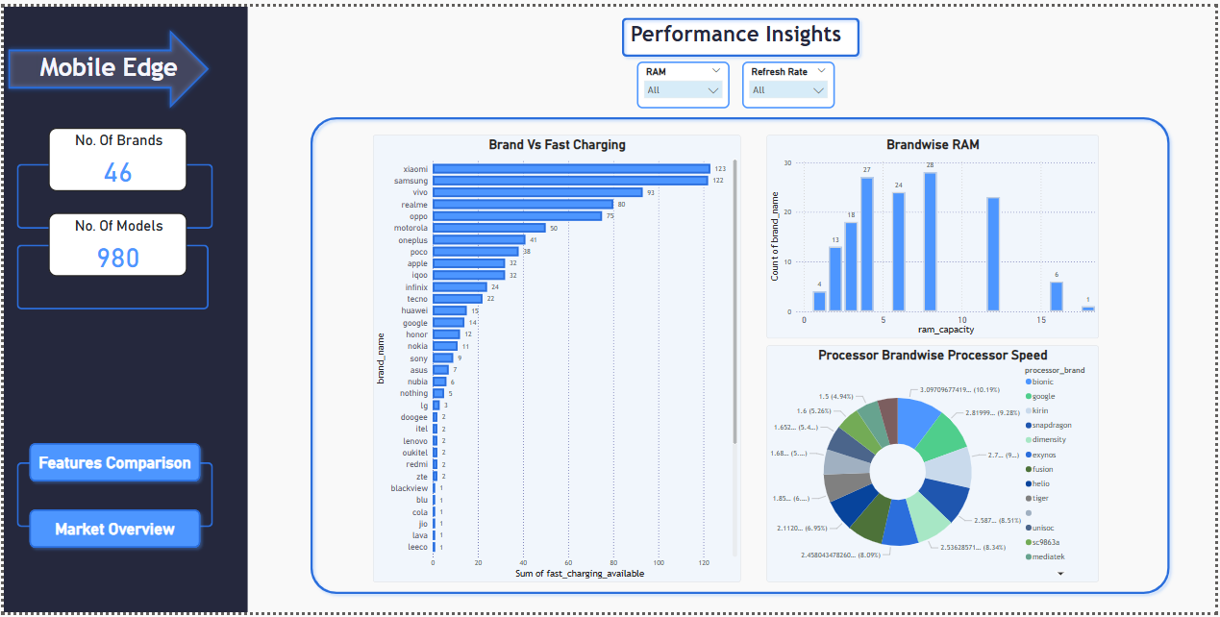

### 1****. Brand vs Fast Charging Support****

“A **bar chart** showing how many smartphone models per brand support **fast charging**.”  
 **Xiaomi** and **Samsung** lead in offering **more fast-charging-enabled phones**, improving user convenience.

### ****2. Brand-wise RAM Capacity****

“A **bar chart** showing how many brands offer various **RAM capacities**.”  
4, **6 GB and 8 GB** RAM are the most common across multiple brands, balancing performance and cost.

### 3****. Processor Speed Distribution by Brand****

“A **pie chart** displaying the **processor speed distribution** across different processor brands.”  
This helps identify which brands dominate the **high-performance segment** based on average speed.